Society Safeguarding Guide.
This guide should be a basic provision to help you as Committee Members, understand what Safeguarding is; the how, when and why you should be utilising the Safeguarding Policy; and how this can help to protect yourself, your Members and the wider General Public.

To learn more about the University of Dundee Safeguarding Policy then click here.

What is Safeguarding?
The University of Dundee has a legal obligation to ensure that everyone in their Community feels and more importantly, is safe. Enter Safeguarding. This is the policy and team that the University uses to help promote the health and wellbeing of its Community, protect them from harm and address any Concerns raised.

A Safeguarding Concern could arise whenever:
- An individual is being subject to or is at risk of abuse, neglect or harm.
- An individual is or is at risk of being radicalised.
- An individual has abused, neglected, or caused harm to someone else.
- An individual’s behaviour is considered to be a Serious Issue.

How to Report a Concern:
Reporting a Safeguarding Concern is extremely easy and can be done both whilst remaining anonymous or without.

To raise a Concern without remaining anonymous, you should use this form.

To raise a Concern whilst remaining anonymous, you should visit this page to learn more about how you can get in contact depending on the situation.
- Please note, that anonymous Concerns may restrict, delay or prevent any formal action depending on the situation and provision/absence of compelling evidence which speaks for itself.

If a Concern is an emergency or urgent then the Concern should be reported to the police (if a criminal matter) by calling them either at 999 or 112 on a phone. Alternatively, if you have a Concern about a member of staff or student out of hours then you should call University Security (24/7 service) by calling 01382 385850.
- There are also 6 assistance points across Campus which allow you to call Security and remain under video surveillance and constant communication with the main Security Team whilst a smaller team is dispatched to attend to you.

When to Report a Concern:
Earlier we covered what the University of Dundee considers as a Safeguarding Concern as per their website.

Overall, our advice to you is that if you have any concerns for the overall wellbeing for an individual, whether it be that they are at risk of harm or of causing harm, to themselves or others - mental, physical, emotional or otherwise. Then contact Safeguarding as soon as possible, and they will be able to step in and help to triage the situation and ensure the relevant help is provided to all parties.

It does not matter if your Concern wasn’t listed above. If you’re concerned, then get in touch with Safeguarding.

Why Report a Concern?
Firstly, why not? If you don’t raise a Concern and something happens to an individual, then the guilt could be overwhelming. If you raise a Concern and the individual turns out to be fine, then it is better to be safe than sorry. In the long run, they will most likely appreciate that you were looking out for them!

Moreover, as a Society Committee Member, whether you believe it or not, you are in a position of power and influence. As such, you have a degree of responsibility for ensuring the safety and support of your Society Members. There are times when only you will notice that something is ‘off’ about a Member:
- Become distant/changes in behaviour.
- Hanging around the outskirts of events.
- Stop turning up to events.
- Begin drinking more or engaging in risk taking behaviour.
These are just some of the things that people in Society Committee’s might be able to notice more than anyone else and all are potential causes for Concern, albeit some more than others.

Similarly, being in such a position of note in your Community means that people are much more likely to approach you and talk to you about matters that concern them or how they’re feeling. This is especially the case where people are often anxious about approaching formal authority figures and support services and would rather the support of a peer and someone like them.

Finally, if you’re ever on the fence about raising a Concern then get in touch with Safeguarding directly (safeguarding@dundee.ac.uk), the DUSA Advice and Support Team (advice@dusa.co.uk) or ourselves (societies@dusa.co.uk). You will then be supported in making a decision.

Important Things to Remember:
- Safeguarding isn’t simply about punishment. Safeguarding will seek to ensure that everyone receives the relevant support throughout the whole process and are more interested in protecting the individuals than necessarily punishing them flat out.
However, that doesn’t mean that Safeguarding doesn’t lead to disciplinary action or intervention by the authorities when it is warranted. For an overview of how a Concern raised might end, please see the images at the bottom of the document.
- DUSA is here to support you throughout the whole process. While we might not necessarily be able to tell you about individual decisions of the Safeguarding Team or outcomes of Concerns due to Data Protection Regulations, we are able to do our best to ensure that you have someone with you during meetings (if you would like them there of course) and that you are signposted to any additional services you might find useful or need. Most importantly, we’re here to support you, not to take sides or pass judgement.
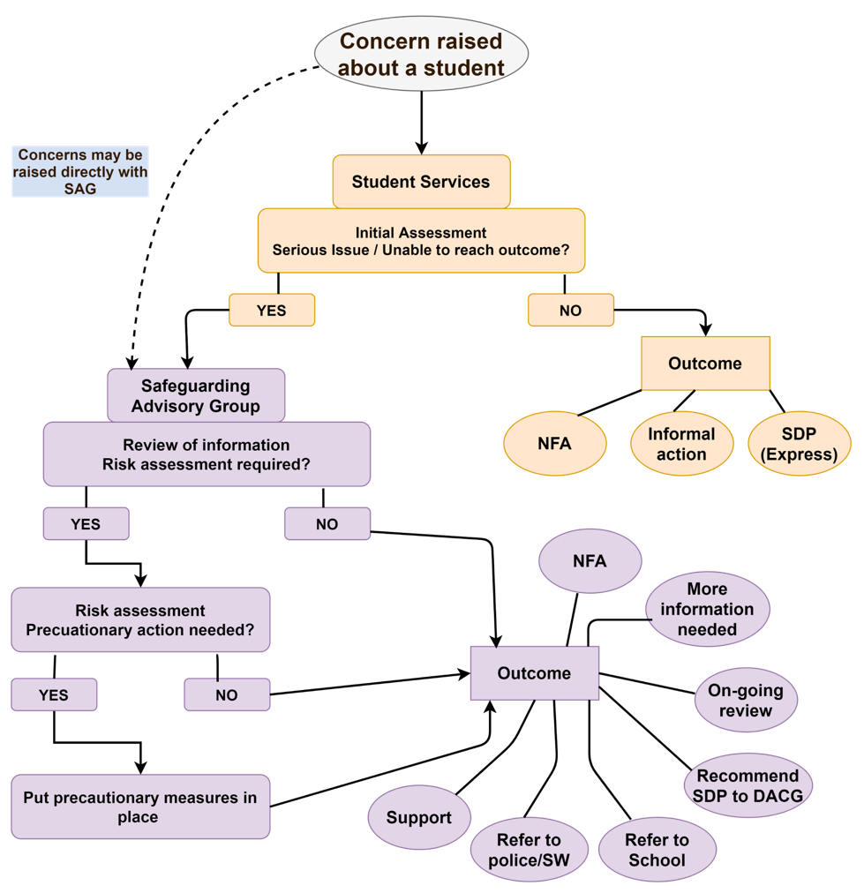
- When dealing with Safeguarding issues concerning your Society Membership, please get in touch with us either in the first instance or after contacting Safeguarding to keep us in the loop and to see how we can help support you and your Society. Simply drop an email to societies@dusa.co.uk to let us know what has happened up to that point.

