**SRC Motions – Guidance on bringing policy to the Council**

**Introduction**

Fundamental to the Students’ Representative Council (SRC) is the role it plays in recommending policy to the Students’ Association and it can cover a wide range of topics and subject areas.

For those Councillors or Students who bring policy to the SRC, this can be a daunting prospect; however, Council members are in a fortunate position and can make positive change for the student body.

Due to the expectations on Councillors when they bring forward a motion, this guidance has been created to help navigate you passed the pitfalls and help construct a competent proposal for presentation and consideration.

***Motions – what are they and what can they be on?***

Motions are a formal policy submission to the SRC. It is up to the Council to discuss and then vote on whether to pass a motion or not.

The motion is formatted into four key sections:

1. *Introduction*

Here you want to briefly outline the purpose of your motion and what it is trying to achieve.

1. *General information*

This is where you can provide the background and any evidence you want to present to back it up

1. *Conclusion + Motion*

The final part is where you can provide closing remarks and present what you want the Council to vote on.

1. *Timeline*

Here you can provide a timeline of next steps of your motion and provide a date for when you would like these actions to take place, given the motion is passed.

It is good practise to have one or more seconders on a motion as this provides you with the chance to show the level of support you have from the Council and that you have considered a range of views prior to bring it forward. It is expected that seconders will have **made sure they understand** what they are supporting.

**We have placed a template in appendix 1**.

*Legal Framework*

Dundee University Students’ Association (DUSA) is a registered Scottish Charity and as such has a set of objectives it must work towards. This means that all its efforts and resources should be focused on achieving these aims:

* Prevention or relief of poverty
* The advancement of education
* The advancement of health
* The advancement of citizenship or community development
* The advancement of the arts, heritage, culture or science
* The advancement of public participation in sport
* The provision of recreational facilities, or the organisation of recreational activities, with the object of improving the conditions of life for the persons for whom the facilities or activities are primarily intended
* Promotion of equality and diversity
* The relief of those in need by reason of age, ill health, disability, financial hardship or other disadvantages

This is important for you to be aware of because if you present a policy out with these then there might be little, we can do about it. You should seek advice from the Executive to help identify what you are proposing fits within what DUSA can legally do.

In addition, DUSA must work within Education and Charity law and guidance at all time. You should refer to, in particular:

* [Education Act 1994](https://www.legislation.gov.uk/ukpga/1994/30/part/II)
* [Charities and Trustees Investments (Scotland) Act 2005](https://www.legislation.gov.uk/asp/2005/10/contents)
* [OG48](http://ogs.charitycommission.gov.uk/g048a001.aspx)

*Developing your idea*

When beginning the process to develop your policy proposal, you need to get a clear understanding of the issue you are trying to tackle.

Here research is vital and there are a number of sources you can use to help you get a better understanding. Your first port of call is to work with the relevant DUSA Executive Officers and support staff as well as your sub-committees. This can first of all identify whether the policy is something the Association can actually do and provide you with an invaluable resource to develop and improve on your goals.

Often policy that comes forward focuses on operations of DUSA and there is a range of staff members who you can contact to help you shape the policy so it meets the Association’s and students’ needs.

*Policy Triangle*

To provide a framework to help you develop your ideas into a coherent policy, the “Policy Triangle” outlines important areas you should ensure are considered before submitting to the Council.

The “Triangle” highlights four initial areas including:

**Content:**

The content is your actual policy idea including what type of idea it is, what is required, who it is impacting, what are the outcomes etc.

**Context:**

These are the situational, structural, cultural and environmental factors that the issue, the solutions and the development of the policy is surrounded and impacted by.

**Process:**

This is the key steps in bring the policy into being – who needs to be involved, what actions you are taking to develop it, where does it need to go and who needs to decide on whether it will be taken forward?

**Actors:**

Who are the key stakeholders, who are your influences, who has the ideas to make it work?

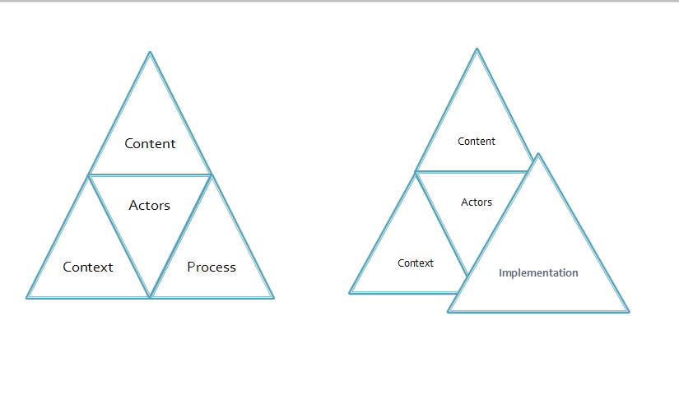

However, it is vital to remember that all policy falls down if how it is to be “implemented” has not been thought out properly. You need to consider not only if it achievable but have a sense of how it can be done. To help you do this there is a simple process you can go through to help you develop your ideas:

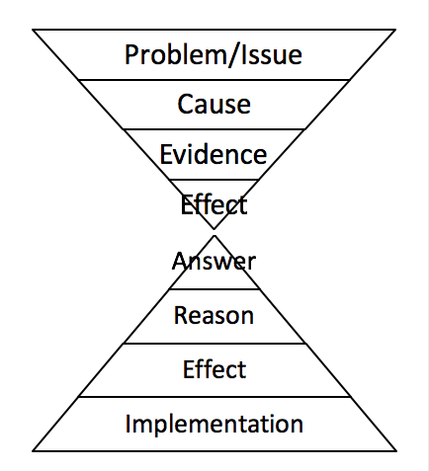

##### Problem/issue

You need to identify what the problem or issue is that you are trying to resolve. Be clear and take one at a time.

**Cause**

Here you want to outline the key reasons why the problem exists and persists. This is important as you are identifying what you want to remove and helps ensure you have a full understanding of why it is happening.

**Evidence**

This is where you need to consider the evidence for the causes. Assumption and perception can help but having proper facts is much better.

**Effect**

Here you want to outline how the problem/issue affects students and their experience. This can help you understand and communicate the impact it is having.

**Answer**

Here is where you can outline your solutions to the problems you have identified.

**Reason**

At this stage you need to provide the reasons why your solutions are the right ones.

**Effect**

You want to outline the positive effects that your answers/solutions will bring to students, DUSA and the university.

**Implementation**

Good ideas often fail because people don’t consider how they are going to implement them. You need to be clear about how your solutions can be taken forward by you and others and make sure they are realistic.

*Strengths, Weaknesses, Opportunities, Threats*

In the development of your ideas and especially when considering the implementation phase, it may be worth undertaking a “SWOT” analysis; which stands for “Strengths, Weakness, Opportunities and Threats”. An easy way to think about it is:

* Strengths and Weaknesses – are what you have to consider internally. That might be a specific resource that the Students’ Association has or lack of that resource.
* Opportunities and Threats – are external considerations such as key groups that you can bring into help or impending legislative changes which might derail your work.

You may not have all the information to hand so again this is something you should do with support from your sub-committees/SVSO, friends, colleagues and DUSA. Below is a template to help you develop a SWOT:

As part of your motion it would be helpful to show that you have undertaken such a process with additional information such as potential timelines and other planning tools.

**Conclusion**

We hope that this guide will help you in writing your policies across the year. There is a lot of help available for you and real achievement comes from working together to develop strong solutions to improving the student experience.

**Appendix 1**

**SRC Motion Template**



**Paper:**

**Paper Title:**

**Date:**

**Motion type: [Actioning or Supporting- delete as appropriate]**

**Author/proposer:**

**Position:**

**Seconder/s:**

**Position/s:**

**Introduction**

**General information**

**Conclusion + Motion**

**Legacy Timeline**